In the Operation Theatre

- Do not worry. Phaco surgery is a painless and bloodless procedure and it takes only 7 minutes.
- No injection, stitches or bandage is given during surgery.
- You will be admitted in the morning. Take bath and light breakfast before admission. Continue all other medicines you are taking regularly for other ailments.
- You will walk in and walk out normally from the OT.
- Lie down on the table in supine position with chin up.
- We will place a thin perforated paper to cover your face, so that no germs can enter in the operating area from your nose or mouth. You can breathe normally and comfortably, preferably through open mouth during surgery.
- During operation, keep both the eyes wide open and stare at the focussing light. It eases the pressure on your eyes.
- If you experience any problem tell us immediately. Do not raise your hand or move your head, it may hamper your surgical procedure.
- During surgery, do not hold your breath, respire normally and try to get relaxed. A tensed patient makes the task difficult for the surgeon.

Enjoy the experience of more than 9,000 successful Phaco Surgery

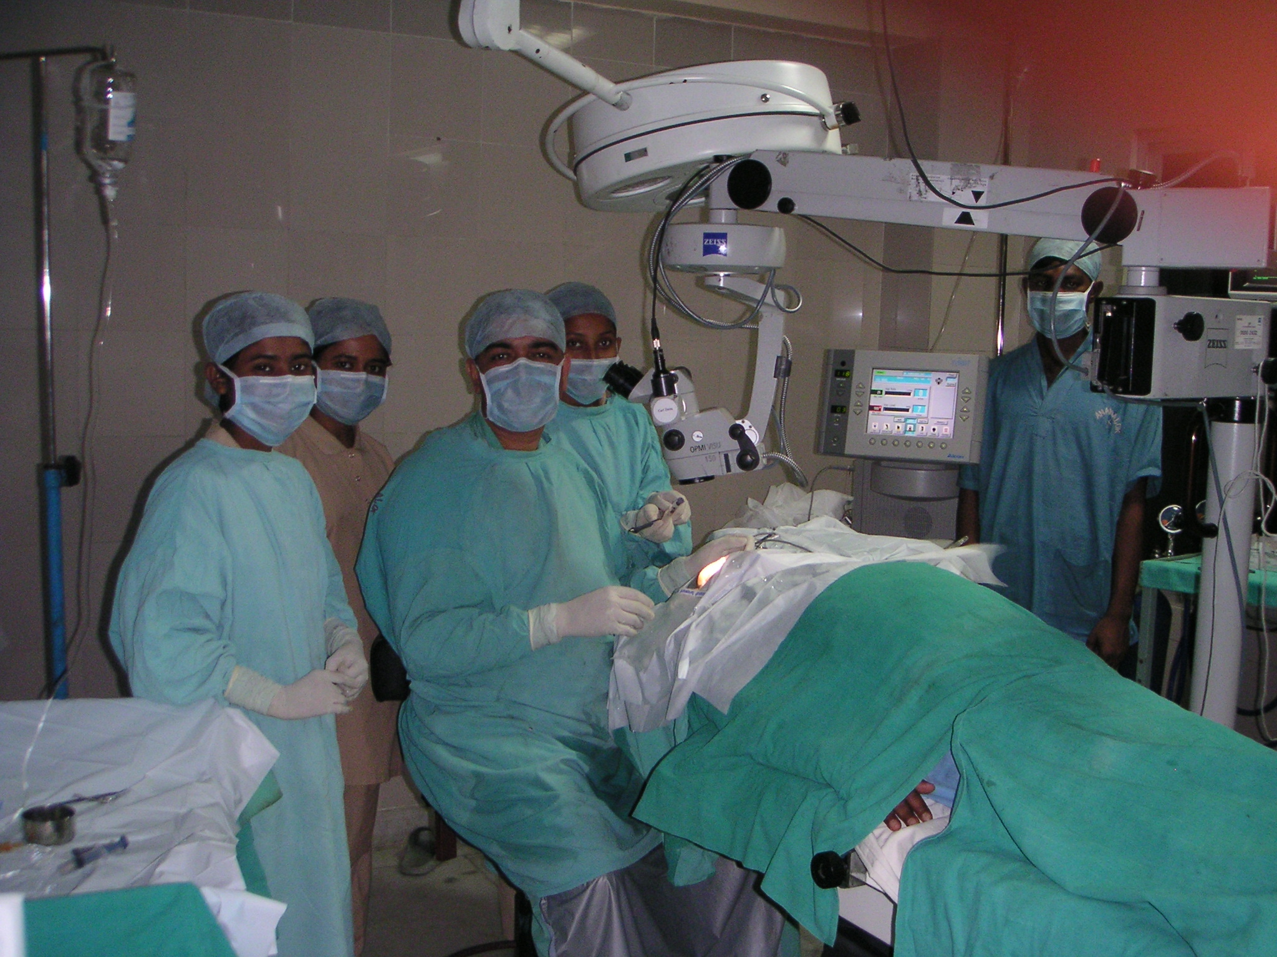
After Phaco Operation

- You can go home a few hours after operation with open eyes. There will be no harm in the dust and pollution during your journey. You can climb stairs and can bend your head normally.
- No dark glasses, eye guard or dressing is needed. You can use your old glasses if you feel comfortable.
- You can eat or drink whatever you wish, sweet or sour everything can be taken. You can chew betel leaves, supari or any hard foodstuff.
- Take all other medicines you are taking regularly for other ailments. You can consult any doctor for other problems and undergo their treatment simultaneously.
- Any eye drop prescribed should be put 1 drop each time in the operated eye only after pulling down the lower eyelid and then keep eyes closed for 2 minutes.
- From the next day you can do everything normally, watching TV, reading newspaper, morning walk, doing exercises, shaving, taking head bath, doing some kitchen work, lifting heavy objects, lie down on any side. Nothing will go wrong if some water goes in your eyes during bath or if you have cough or sneeze.
- The other eye can be operated on the following day. Vision will be even better when both eyes are done. A glass will be prescribed later to have finer vision.
- For a few months following surgery, there may be slight watering, discomfort or gritty sensation. Do not worry. Splash plain water frequently in the open eye to keep it moist.
- For any problem or query, you can come on any day at our clinic without prior appointment. Do not ask for suggestion or assistance from your acquaintances. Call us at our helpline 9836035033 otherwise consult your local eye practitioner if you are unable to reach us.

